To access the English Sinuiksi chats, you need to navigate the Finnish language tukinet.net site. The easiest way to do that is to use Google Chrome as your browser and use its inbuilt translator function. However, if you cannot use the browser or its translation function does not work, this guide will help you set up.
First, you need to register on the site by clicking “rekisteröidy” in the main menu.

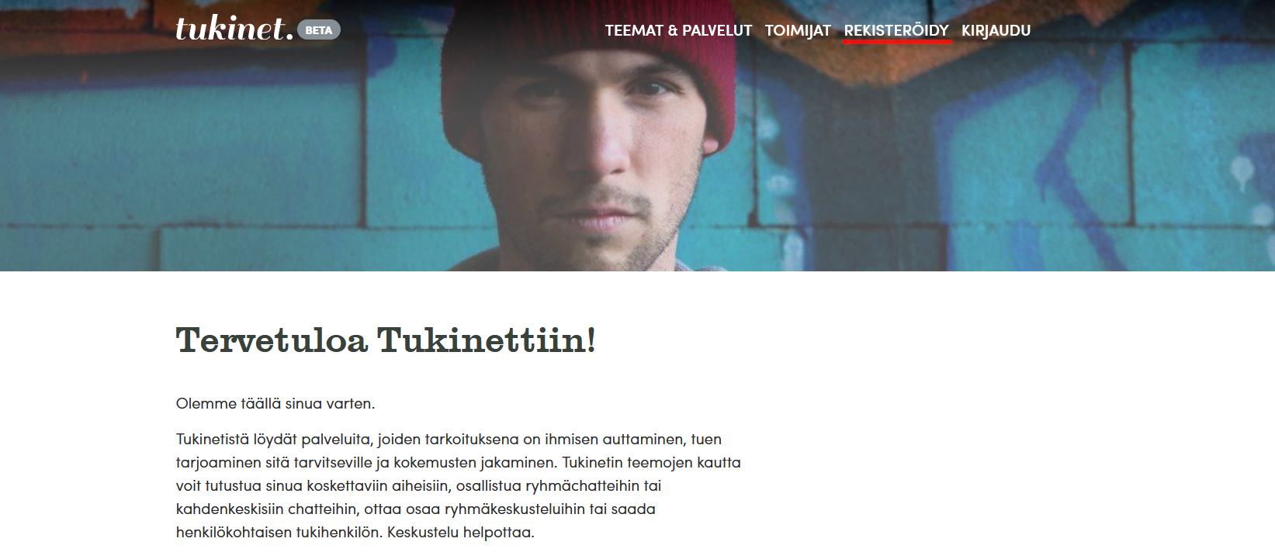

You will be confronted with a registration screen, translated here for your convenience.
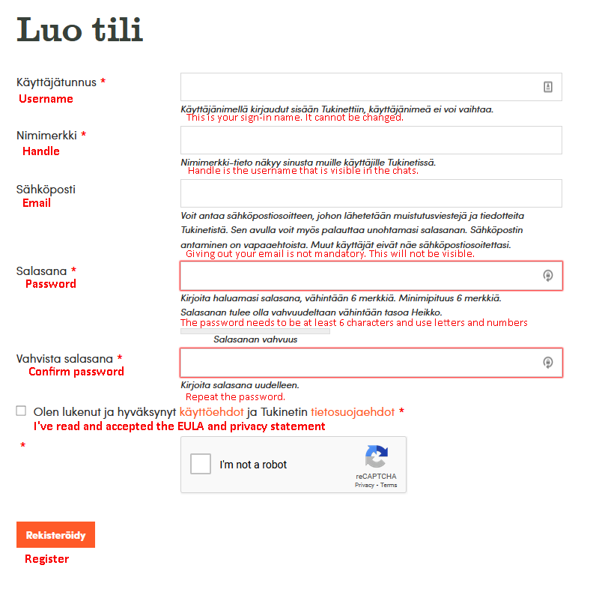
On subsequent visits, you need to sign in to the site.
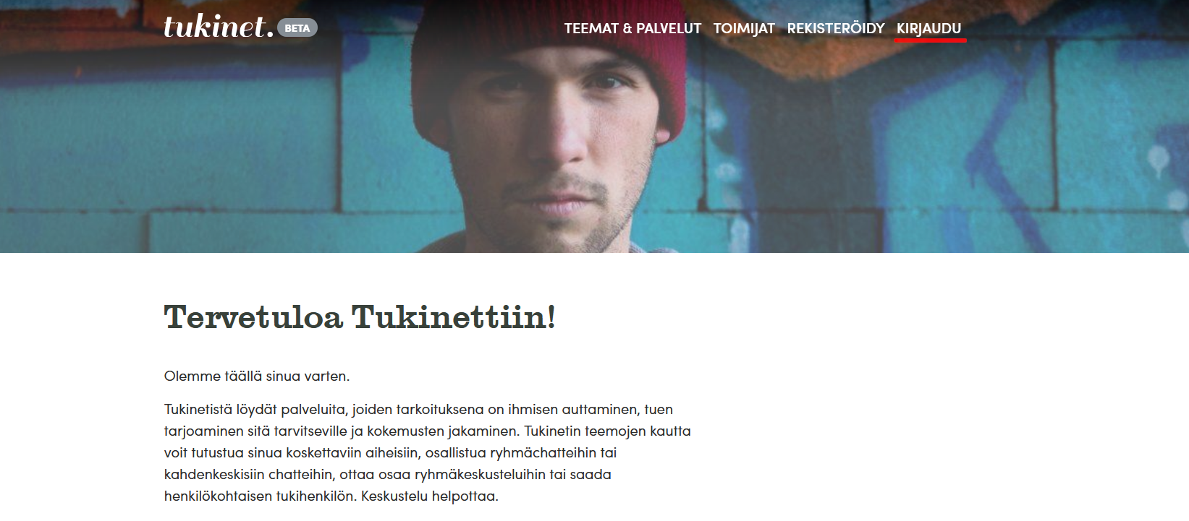

You will see a sign-in screen like this. Again with translation
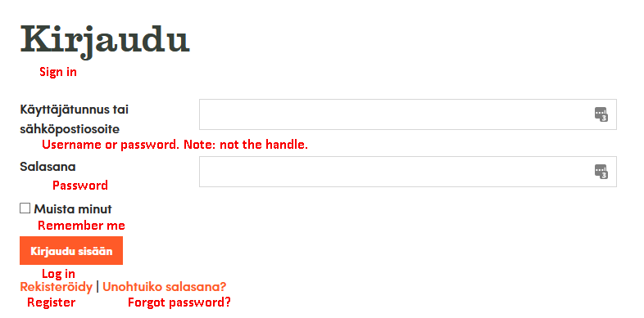
e-mail.
Once you are logged in, you can find the chat on the front page of the site, or from direct link on the sinuiksi.fi calendar or at the Tukinet site (https://tukinet.net/teemat/sinuiksi-chat-sateenkaari-ihmisille/ryhmachatit/).
To enter a chat, all you need to do is press this button to enter:
Welcome, and don’t forget to read the rules!

